**Project Design Phase-II**

**Data Flow Diagram & User Stories**

|  |  |
| --- | --- |
| Date | 24 June 2025 |
| Team ID | LTVIP2025TMID52981 |
| Project Name | Orderonthego |
| Mentor Name | Dr Shaik Salma Begum |
| Maximum Marks | 4 Marks |

**Data Flow Diagrams:**

A Data Flow Diagram (DFD) is a traditional visual representation of the information flows within a system. A neat and clear DFD can depict the right amount of the system requirement graphically. It shows how data enters and leaves the system, what changes the information, and where data is stored.

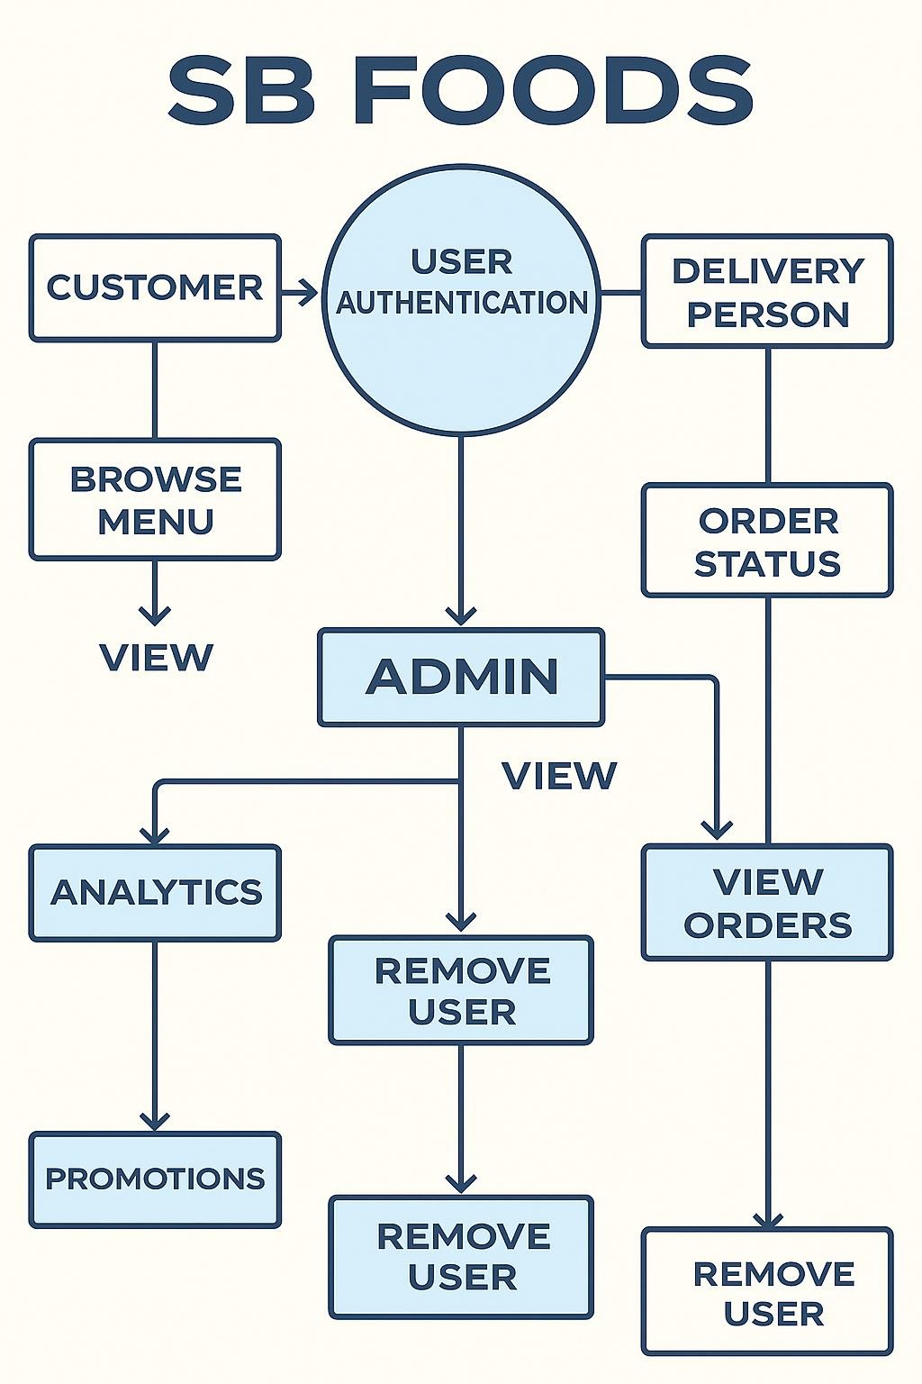

**Example: [(Simplified)](https://developer.ibm.com/patterns/visualize-unstructured-text/)**

**User Stories**

Use the below template to list all the user stories for the product.

| User Type | Functional Requirement (Epic) | User Story / Task | Acceptance Criteria | Priority |
| --- | --- | --- | --- | --- |
| Customer | Restaurant Search & Ordering | As a customer, I can search for restaurants by cuisine and location. | Search results return relevant restaurants. | High |
| Customer | Restaurant Search & Ordering | As a customer, I can place, modify, or cancel food orders. | Order status updates accordingly. | Medium |
| Restaurant Owner | Order & Menu Management | As a restaurant owner, I can manage my menu and availability calendar. | Changes reflect immediately in customer app. | High |
| User | Messaging | As a user, I can chat with restaurants or delivery agents in real-time. | Messages appear instantly. | Medium |
| Admin | Profile Management | As an admin, I can update my profile. | Changes are saved successfully. | High |
| Customer | Payment Processing | As a customer, I can make secure payments for my orders. | Payment recorded and shown in transaction history. | High |
| User | Review System | As a user, I can leave a review after order completion. | Review appears on restaurant profile. | Medium |
| Admin | User Moderation | As an admin, I can review reported users and take action. | Reports and actions logged. | High |